**JavaScript:**

**What is JavaScript?**

The language was initially called LiveScript and was later renamed JavaScript

* JavaScript is a very powerful **client-side scripting language**.
* JavaScript is used mainly for enhancing the interaction of a user with the webpage.
* In other words, you can make your webpage more lively and interactive, with the help of JavaScript.

**Features of Java Script:**

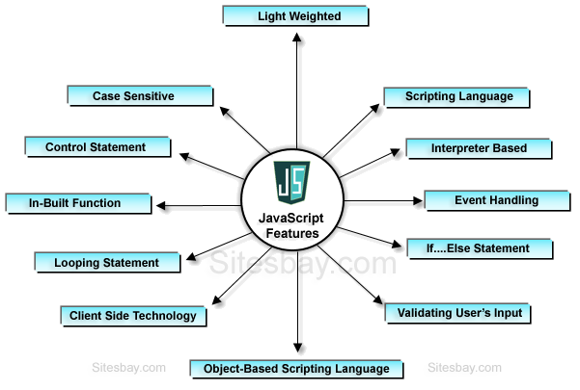

**Limitations of JavaScript:**

* Client-side JavaScript does not allow the reading or writing of files.
* It cannot be used for networking applications because there is no such support available.
* It doesn't have any multithreading or multiprocessor capabilities.

**Tools for Java Script:**

We can use any text editor of our choice including

* Notepad++
* Visual Studio Code
* Sublime Text
* Atom or
* any other text editor

You can use any web browser including

* + Google Chrome
  + Firefox
  + Internet Explorer
  + Microsoft Edge, etc

**How to Run JavaScript?**

Step -1 Open Notepad or any text Editor

Step -2 Write HTML code with Java Script

Step -3 Save the file with extension .html

Step -4 Open file using any Web browser

**SCRIPT Tag:**

The <SCRIPT> tag is an extension to HTML that can enclose any number of JavaScript statements as shown here:

<SCRIPT>  
 *JavaScript statements..*.  
</SCRIPT>

* A document can have multiple SCRIPT tags, and each can enclose any number of JavaScript statements.

**Famous “Hello World” Program:**

<!DOCTYPE html>

<html>

<body>

<script language="JavaScript">

document.write(“Hello, World!”)

</script>

</body>

</html>

**Script Where To use:**

* You can place any number of scripts in an HTML document.
* Scripts can be placed in the <body>, or in the <head> section of an HTML page, or in both.
  + With in body section
  + With in head section
  + External file

**JavaScript Display Possibilities:**

* JavaScript can "display" data in different ways:
  + - Writing into the HTML output using document.write().
    - Writing into an HTML element, using innerHTML.
    - Writing into an alert box, using window.alert().

(alert, prompt, confirm)

**Using innerHTML:**